# PROJECT REPORT

Project Title:

*STUDENT PERFORMANCE ANALYSIS*

Team ID : LTVIP2023TMID00368

Team Size : 5

Team Leader : KORADA ANJALI

Team member : KORNANA ESWARAMMA

Team member : MAJJI PRASANTHI

Team member : POTIPIREDDI PAVANI

Team member : REVALLA SAI

|  |  |  |
| --- | --- | --- |
| **1**  **2**  **3**  **4**  **5**  **6**  **7**  **8** | **Introduction**  1.1 Overview  1.2 Purpose    **Literature Survey**  2.1 Existing Problem  2.2 Proposed Solution    **Theoritical Analysis**  3.1 Block diagram  3.2 Hardware/Software Designing    **Result**    **Advantages & Disadvantages**    **Applications**    **Conclusion**    **Future Scope** | 2 |

# STUDENT PERFORMANCE ANALYSIS

**Introduction:**

This document provides a comprehensive analysis of student performance. It aims to help educators and policymakers understand the factors that impact student performance and identify strategies for improvement. The analysis includes:

**Literature survey:** A review of existing research on student performance, including studies on academic achievement, attendance rates, and graduation rates.

**Theoretical analysis:** A critical analysis of different theories and frameworks that explain the factors affecting student performance, such as socio-economic status, parental involvement, and teaching quality.

**Results:** A detailed discussion of the findings from the research, including data on student performance, the factors that affect it, and the effectiveness of different interventions.



**Recommendations for improvement:** Based on the analysis, the report provides recommendations for improving student performance, such as early intervention programs, personalized learning, equal access to education, and smaller class sizes.

**Future Scope:** The report concludes with a discussion of the future scope of the research and the areas that need further investigation to improve student performance.

## Overview

Student performance analysis is the process of examining and evaluating the academic achievements and progress of students in educational settings. It involves gathering and analyzing data related to students' academic performance, behavior, attendance, and other relevant factors to gain insights into their strengths, weaknesses, and overall performance. This analysis helps educators, administrators, and policymakers make informed decisions to improve the learning outcomes and educational experiences of students.

Here's an overview of the key aspects of student performance analysis**:**

**1.Data Collection:** The first step in student performance analysis is the collection of relevant data. This may include academic records, test scores, grades, attendance records, and behavioral data. Additionally, data from various assessments and standardized tests may also be included.

1. **Performance Metrics:** To assess student performance, various metrics are used. These can include average grades, class ranks, test scores, pass/fail rates, dropout rates, and performance trends over time.

1. **Identifying Patterns:** By analyzing the collected data, patterns and trends can be identified. These patterns might reveal subject areas where students excel or struggle, areas with high absenteeism rates, or periods when student performance tends to decline or improve.

1. **Individual Student Assessment:** The analysis can be applied to individual students to understand their unique strengths and weaknesses. This can help in providing personalized interventions and support to help students reach their full potential.

1. **Curriculum Evaluation:** Student performance analysis can also aid in evaluating the effectiveness of the curriculum and teaching methods. It can help identify areas where the curriculum may need improvement or where teaching strategies need adjustment.

1. **Interventions and Support:** Based on the insights gained from the analysis, educators can develop targeted interventions and support systems. These might include additional tutoring, mentoring, or implementing specific teaching strategies to address the needs of struggling students.

1. **Accountability and Policy Making:** Analyzing student performance data is crucial for educational policymakers and stakeholders. It provides evidence for accountability measures and helps in shaping educational policies that aim to improve the quality of education.

1. **Tracking Progress:** Continuous analysis of student performance allows educators to track the progress of interventions and determine their effectiveness over time. This helps in refining strategies and making data-driven decisions.

In conclusion, student performance analysis is a valuable tool for understanding student achievements, identifying areas for improvement, and guiding educational decision-making to foster better learning outcomes for students.

# Purpose

The project on student performance analysis serves several important purposes and offers various uses in the field of education. Some of the key uses of this project are as follows:

**1.**Improving Academic Performance:\*\*** The primary use of this project is to improve the academic performance of students. By analyzing their performance data, educators can identify areas of strengths and weaknesses, tailor instruction to individual needs, and implement targeted interventions to support struggling students.

1. **\*\*Data-Driven Decision Making:\*\*** The project promotes data-driven decision making in educational institutions. By basing decisions on empirical evidence and insights gained from performance analysis, schools can make more informed choices about curriculum, teaching strategies, resource allocation, and policy development.

1. **\*\*Personalized Learning:\*\*** With the help of student performance analysis, educators can create personalized learning plans for each student. This ensures that students receive the appropriate level of challenge and support to reach their full potential.

1. **\*\*Early Intervention and Support:\*\*** The project enables the early identification of students who may be at risk of academic difficulties or falling behind. Early intervention and support can be provided to these students to prevent further challenges and ensure academic success.

1. **\*\*Curriculum Evaluation and Improvement:\*\*** Performance analysis helps in evaluating the effectiveness of the curriculum. Educators can identify areas that need improvement and refine the curriculum to better align with learning objectives and student needs.

1. **\*\*School Improvement Initiatives:\*\*** By conducting performance analysis at a school-wide level, educational institutions can identify trends and patterns that may impact overall school performance. This data can be used to design targeted improvement initiatives to enhance the quality of education provided.

1. **\*\*Parent-Teacher Collaboration:\*\*** The project fosters better communication and collaboration between parents and teachers. Parents can be informed about their child's academic progress, strengths, and areas for improvement, leading to more effective support at home.

1. **\*\*Educational Policy Development:\*\*** The insights gained from student performance analysis can inform the development of educational policies and reforms at the institutional, district, or national levels. Policies can be tailored to address specific challenges and enhance educational outcomes.

1. **\*\*Enhancing Accountability:\*\*** The project provides data for accountability measures, allowing educational stakeholders to assess the impact of various initiatives and hold institutions accountable for student outcomes.

1. **\*\*Tracking Progress and Growth:\*\*** Continuous performance analysis enables the tracking of individual and group progress over time. This data can be used to monitor the effectiveness of interventions and adjust strategies as needed.

11**.**Interactive Data Dashboard:\*\*** interactive data dashboards are becoming more prevalent in education.These user-friendly visualizations allow educators and administrators to explore student performance data, making it easier to identify patterns and trends.

12**.**Integration of Multiple Data Sources:\*\*** institutions are integrating data from various sources, such as academic records, learning management systems, student feedback surveys,and socialemotional assessments, to gain a comprehensive view of student performance.

In summary, the project on student performance analysis is instrumental in supporting educational institutions in their efforts to enhance learning outcomes, optimize resources, and provide a more tailored and effective learning experience for students. By leveraging data to make evidence-based decisions, schools can create a more successful and conducive learning environment for all students.

## Literature Survey

**1.1Existing problems**

As of my last knowledge update in September 2021, there were several existing problems in the field of student performance analysis and education. One significant issue was the quality and availability of data needed for performance analysis. Many educational institutions faced challenges with incomplete or outdated records, which hindered accurate assessments of student progress. Additionally, the increased use of data analytics in education raised concerns about data privacy and security. It became essential for schools to handle sensitive formation responsibly and comply with data protection regulations.

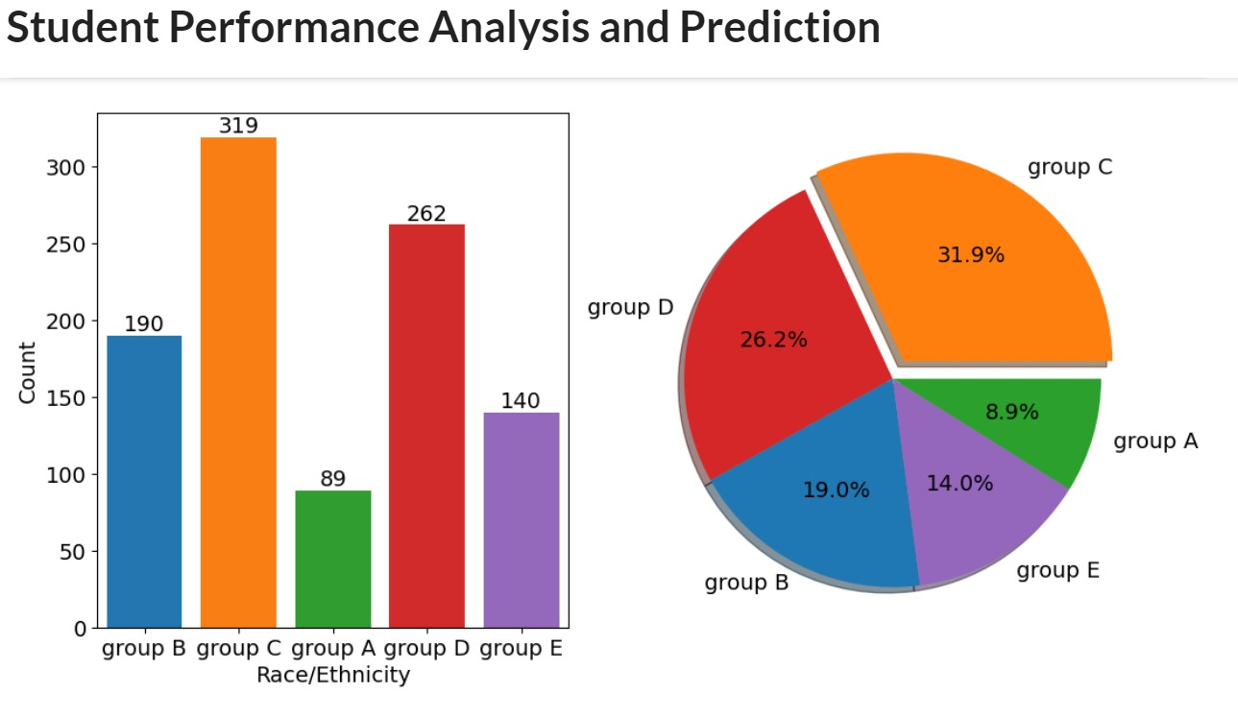

The digital divide remained a prominent challenge, especially in remote or underserved areas. Unequal access to technology and the internet impacted students' ability to participate in online learning, potentially leading to disparities in academic performance.

Furthermore, certain student groups, such as minorities or students with disabilities, faced systemic barriers that affected their academic performance. Addressing these inequalities became crucial to promoting equitable educational outcomes.

Integrating data from various educational tools and platforms proved challenging due to the lack of standardization and interoperability among systems. This made it difficult for schools to have a comprehensive view of student performance. Moreover, many educators lacked training in data analysis, and they struggled to interpret and utilize student performance data effectively. This highlighted the need for teacher training and support in data-driven decision making. Overreliance on standardized testing for assessment was also a concern, as it might limit a comprehensive understanding of students' skills and abilities.

The lack of holistic assessment methods raised questions about capturing students' social and emotional development, creativity, problem-solving skills, and other essential qualities. Teachers' workload increased as they were expected to collect, analyze, and use student performance data while still focusing on classroom instruction. Sustainable funding for implementing robust student performance analysis systems became a challenge for many educational institutions. Furthermore, the COVID-19 pandemic accelerated the adoption of technology in education, leading to new challenges in analyzing student performance in remote and hybrid learning environments.

Addressing these existing problems required collaboration among educational stakeholders, policymakers, researchers, and technology providers. Emphasizing data ethics, investing in teacher professional development, improving data infrastructure, and promoting inclusive and equitable educational practices were student performance analysis and education as a whole.

### 1.2 Proposed solution

To address the existing problems in student performance analysis and education, several solutions have been proposed. First, improving data quality is essential, and this can be achieved through data validation and cleaning processes, coupled with training for staff responsible for data entry. Ensuring data privacy is equally important, and educational institutions should establish robust policies and procedures to protect student information while complying with data privacy regulations. To tackle the digital divide, investing in technology infrastructure and providing access to devices and the internet for underserved communities is crucial.

Collaboration with government and private organizations can help bridge this gap and ensure equitable access to educational resources. Additionally, efforts to promote equity and inclusion in education are essential. Implementing inclusive practices that cater to diverse student needs and providing extra support and resources for marginalized populations can help level the playing field and improve overall academic performance.

Interoperability of systems is a pressing concern in student performance analysis. Encouraging the adoption of standardized data formats and interoperable educational technology systems can streamline data integration and facilitate comprehensive student performance analysis.

Teacher professional development is vital for effective data utilization. Offering training programs on data analysis and interpretation can empower educators to make data-driven decisions and create a datadriven culture within schools. Holistic assessment methods, beyond standardized testing, should be embraced to evaluate social and emotional skills, creativity, and problem-solving abilities more accurately. Promoting social and emotional learning (SEL) integration in the curriculum and establishing SEL assessment frameworks can support students' emotional well-being and overall development. Engaging parents and the community is another crucial aspect.

Creating channels for effective communication and involving parents in their child's learning journey through workshops and events fosters a supportive learning environment. Optimizing resource allocation, prioritizing data analytics tools and professional development for

educators, can lead to effective student performance analysis. Seeking external funding or grants can further support data infrastructure improvements. Additionally, with the changing education landscape, guidelines and best practices for student performance analysis in virtual learning environments should be developed. Providing ongoing support and training for educators can help them navigate the challenges of remote and hybrid learning effectively.

Finally, promoting research and innovation in student performance analysis is essential Encouraging collaboration among educational institutions and stakeholders to share best practices and collectively tackle common challenges can foster continuous improvement in education. Implementing these proposed solutions requires a collaborative effort from educators, administrators, policymakers, and technology providers. By addressing these challenges proactively, educational institutions can enhance student performance analysis, promote equitable education, and improve overall learning outcomes for students.

## Theoritical Analysis

The theoretical analysis of student performance involves examining various theoretical frameworks, models, and factors that may influence how students perform academically. This analysis is crucial for educators, researchers, policymakers, and parents to understand the underlying processes that affect student achievement and to develop effective strategies to improve learning outcomes. Here are some key theoretical perspectives and factors that contribute to the analysis of student performance:

1. **\*\*Cognitive Theories:\*\*** Cognitive theories focus on how students process information, think, and learn. These theories emphasize the importance of memory, attention, problem-solving, and critical thinking in academic performance. For example, renowned cognitive psychologist Jean Piaget proposed the theory of cognitive development, which suggests that students' intellectual abilities change as they grow and mature.

1. **\*\*Social Learning Theories:\*\*** Social learning theories highlight the role of social interactions and observational learning in shaping student behavior and academic performance. Albert Bandura's social learning theory, for instance, emphasizes the impact of role models, peers, and the environment on learning and performance.

1. **\*\*Motivation Theories:\*\*** Motivation plays a vital role in student performance. Theorists like Abraham Maslow (hierarchy of needs) and Frederick Herzberg (two-factor theory) have proposed models to understand what drives individuals, including students, to excel academically.

1. **\*\*Self-efficacy:\*\*** Linked to motivation, self-efficacy refers to an individual's belief in their ability to achieve specific tasks or goals. Students with higher levels of self-efficacy are more likely to persist in challenging academic tasks and perform better.

1. **\*\*Multiple Intelligences:\*\*** Howard Gardner's theory of multiple intelligences suggests that students possess different types of intelligences (e.g., linguistic, logical-mathematical, spatial, musical, etc.), and understanding these individual strengths can inform more personalized approaches to education.

1. **\*\*Learning Styles:\*\*** The concept of learning styles proposes that individuals have preferred methods of learning (e.g., visual, auditory, kinesthetic). Tailoring instruction to match students' learning styles can enhance their understanding and performance.

1. **\*\*Socioeconomic Factors:\*\*** Students' socioeconomic background can significantly impact their access to resources, opportunities, and support, all of which can influence their academic performance.

1. **\*\*Parental Involvement:\*\*** The level of parental involvement and support in a student's education can play a crucial role in their motivation, engagement, and overall performance.

1. **\*\*School and Classroom Environment:\*\*** The school and classroom environment, including teaching methods, resources, and the overall school culture, can influence student performance.

1. **\*\*Educational Policies:\*\*** Government policies, curriculum standards, and assessment methods can shape the overall educational landscape and subsequently impact student performance.

1. **\*\*Emotional Well-being:\*\*** Students' emotional well-being, including stress, anxiety, and overall mental health, can affect their ability to concentrate, learn, and perform academically.

When conducting a theoretical analysis of student performance, it is essential to consider how these various factors interact and influence each other. Each student is unique, and multiple factors may simultaneously impact their academic achievement. Therefore, a comprehensive understanding of these theoretical perspectives can inform more effective educational practices and interventions to support student success.

**Flow Chart:**

Define Problem

Data Collection

Connect DB2 with ibm cognos

Data Preparation

Data Visualization

Dashboard

Report

Story

Performance Testing

Web Integration

### Hardware/software Designing

Designing hardware and software solutions to support student performance can have a significant impact on education. The integration of technology in the learning environment can enhance engagement, personalization, and access to resources. Below are examples of how hardware and software can be designed to improve student performance:

**\*\*1. Hardware Design for Student Performance\*\***

**a.**Interactive Whiteboards:\*\*** Interactive whiteboards in classrooms enable teachers to present content interactively, fostering student engagement and participation. Students can collaborate, solve problems on the board, and visualize complex concepts more effectively.

1. **\*\*Laptops or Tablets:\*\*** Providing students with laptops or tablets facilitates access to digital resources, e-books, and educational apps. It allows for personalized learning experiences and empowers students to explore topics at their own pace.

1. **\*\*Digital Projectors:\*\*** Digital projectors enable teachers to display multimedia content, videos, and educational presentations. Visual aids can enhance comprehension and retention, especially for visual learners.

1. **\*\*Smart Response Systems:\*\*** Smart response systems, like clickers or mobile apps, allow students to participate in real-time quizzes and polls. These tools can be used for formative assessments and instant feedback, helping teachers adjust their instruction based on student understanding.

1. **\*\*Virtual Reality (VR) and Augmented Reality (AR):\*\*** VR and AR technologies can create immersive learning experiences, enabling students to explore historical sites, visit far-off locations, or delve into complex scientific concepts.

**\*\*2. Software Design for Student Performance:\*\***

* 1. **\*\*Learning Management Systems (LMS):\*\*** An LMS is a centralized platform that enables teachers to organize course materials, assignments, quizzes, and grades. Students can access resources and submit work online, promoting organization and communication.

* 1. **\*\*Educational Apps:\*\*** Mobile apps tailored to specific subjects or skills can make learning fun and engaging for students. These apps can offer interactive quizzes, educational games, and tutorials.

* 1. **\*\*Adaptive Learning Platforms:\*\*** Adaptive learning software customizes content and activities based on individual student performance and learning styles. It allows students to focus on areas they find challenging and progress at their own pace.

* 1. **\*\*Collaborative Tools:\*\*** Software solutions that facilitate online collaboration, such as Google Workspace (formerly G Suite) or Microsoft Teams, enable students to work together on projects, fostering teamwork and communication skills.

* 1. **\*\*Assessment and Analytics Tools:\*\*** Data analytics tools can help educators monitor student progress, identify areas of improvement, and provide timely interventions when needed.

1. **\*\*Language Learning Software:\*\*** Language learning apps and software provide interactive lessons, pronunciation practice, and language exercises to support language acquisition.

It's important to note that while technology can enhance student performance, its successful integration depends on proper implementation, teacher training, and appropriate curriculum design. Additionally, access to technology can be a challenge for some students, so ensuring equity and inclusion in technology use is vital for maximizing its benefits in improving student performance.

**Result:**

Creating aa final result of student performance with dashboard reports and a compelling story can provide valuable insights into individual and group achievements,areas of improvement, and overall progress.

#### Dashboard

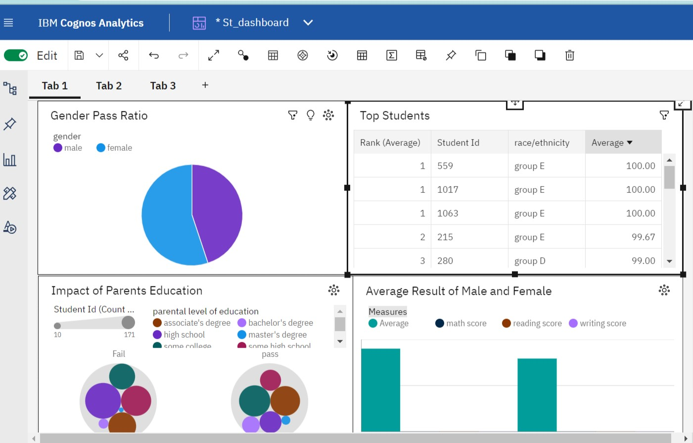

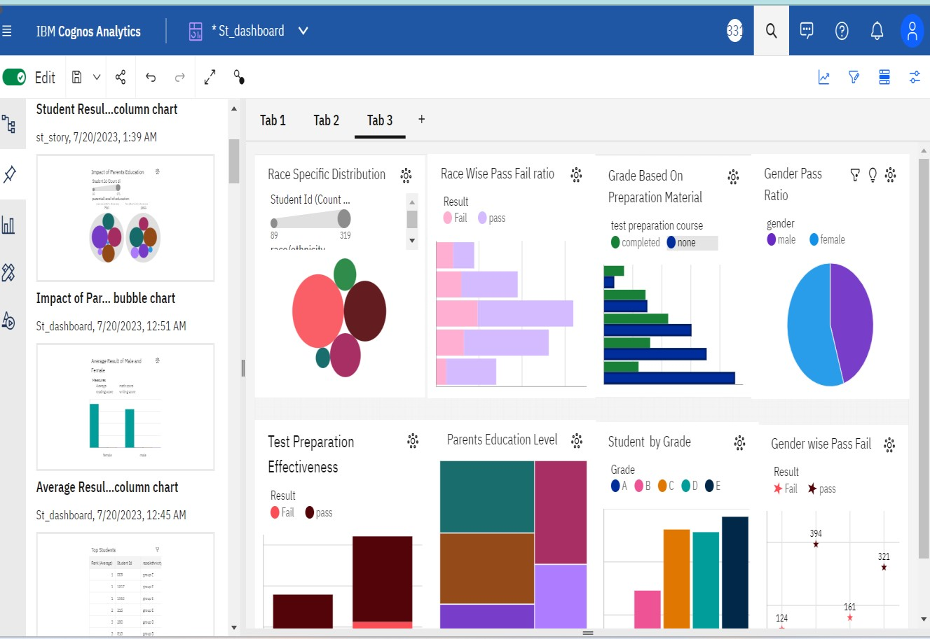

## Story

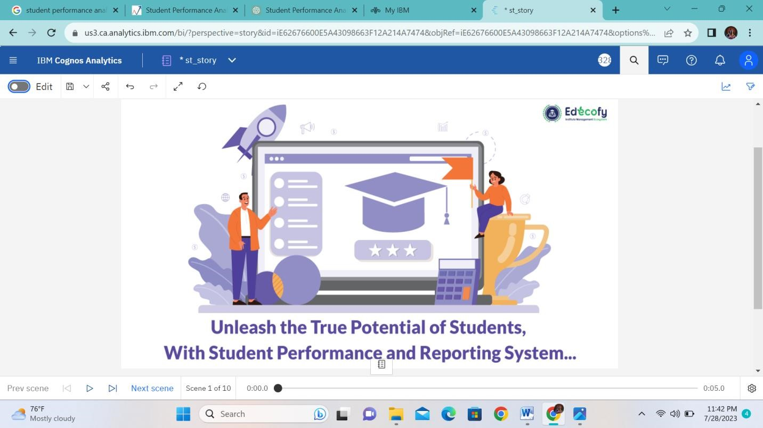

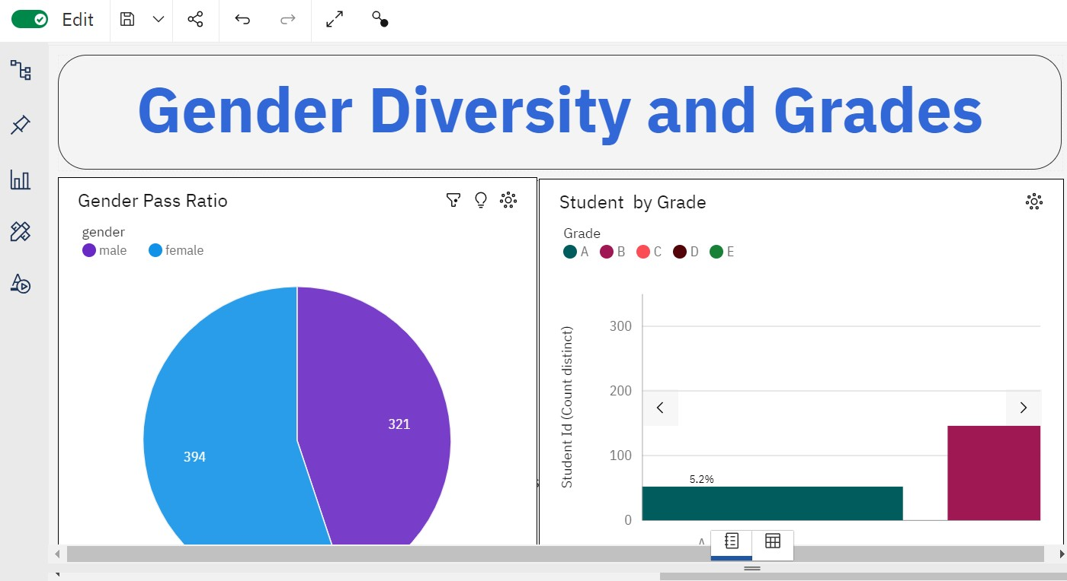

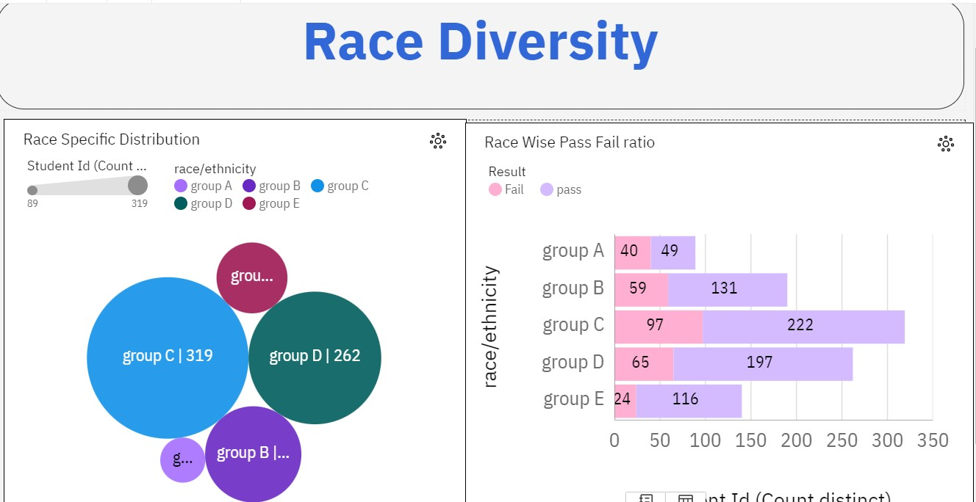

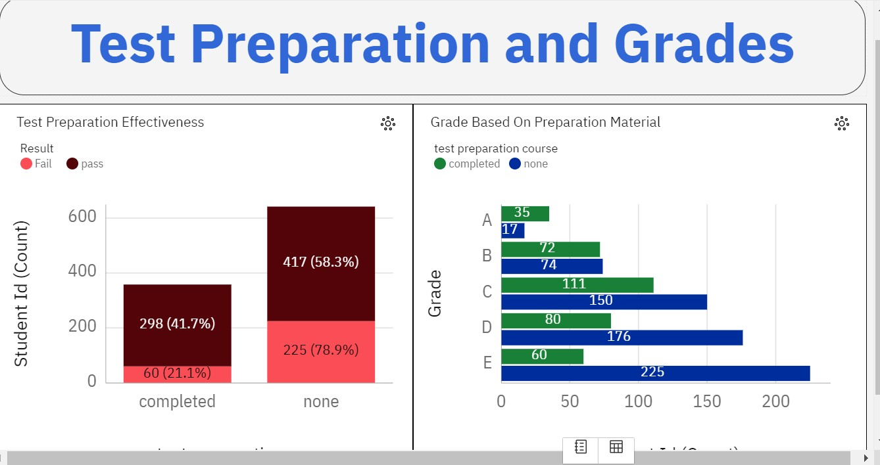

# Report

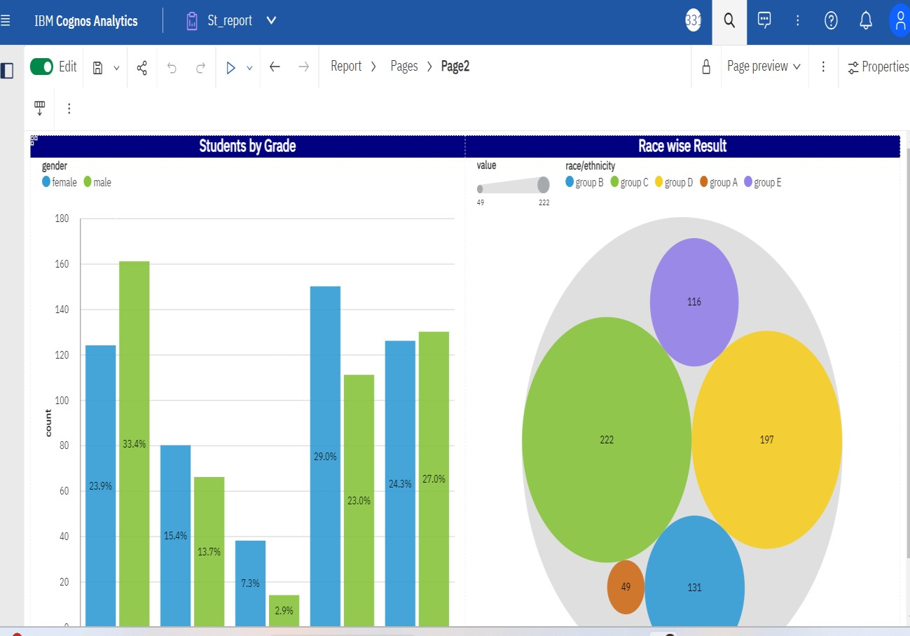

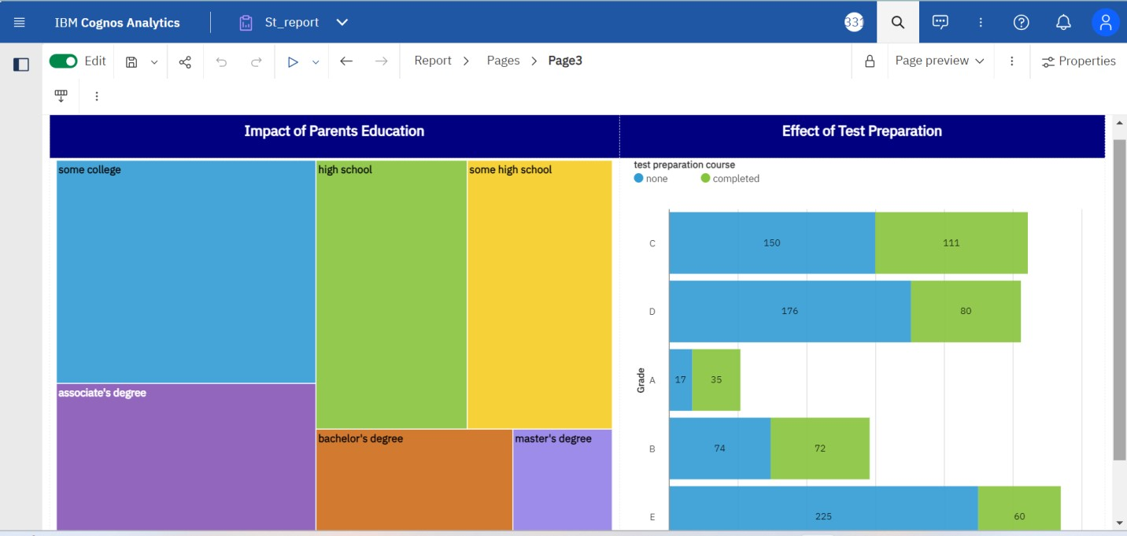

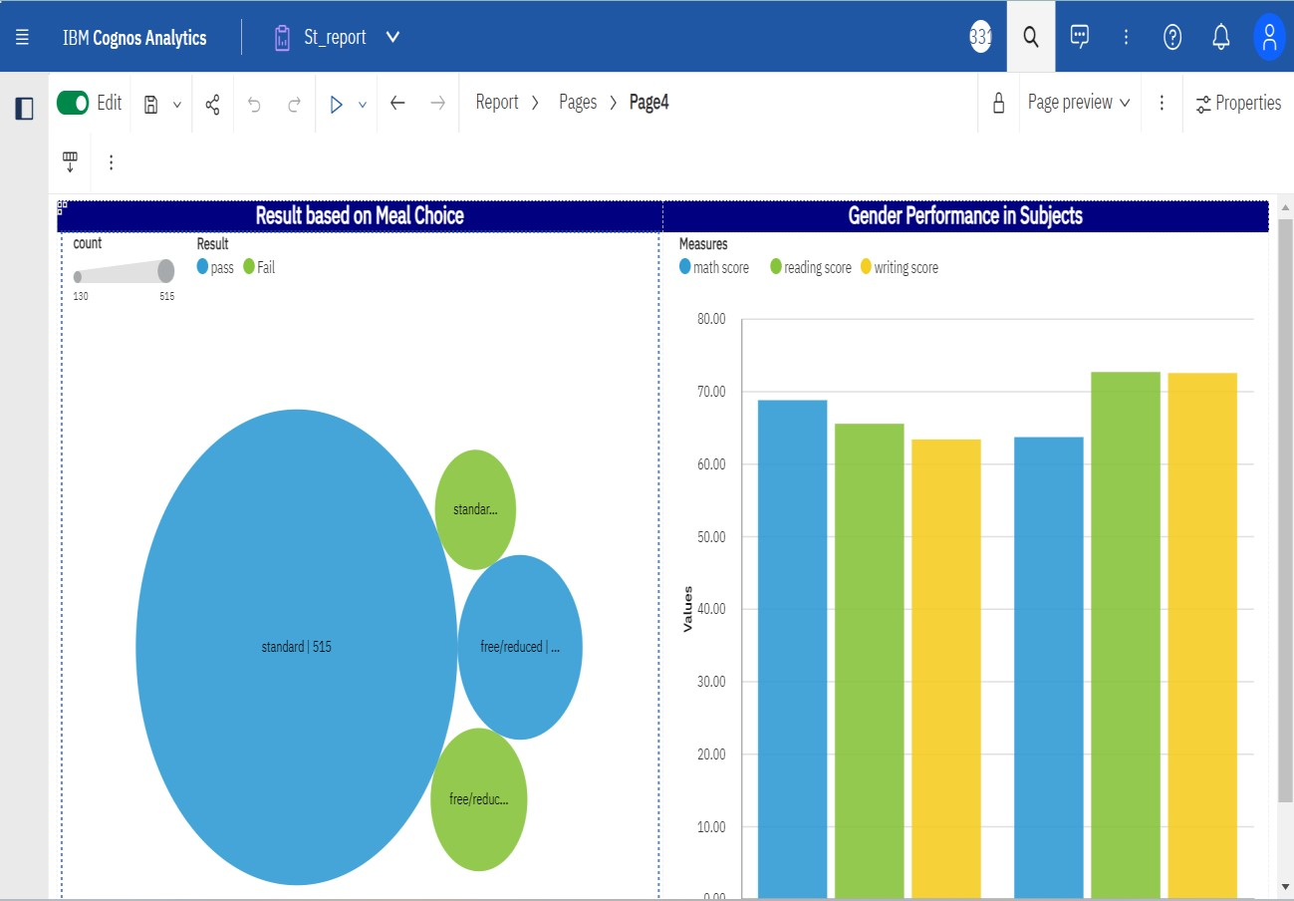

**Web integration**

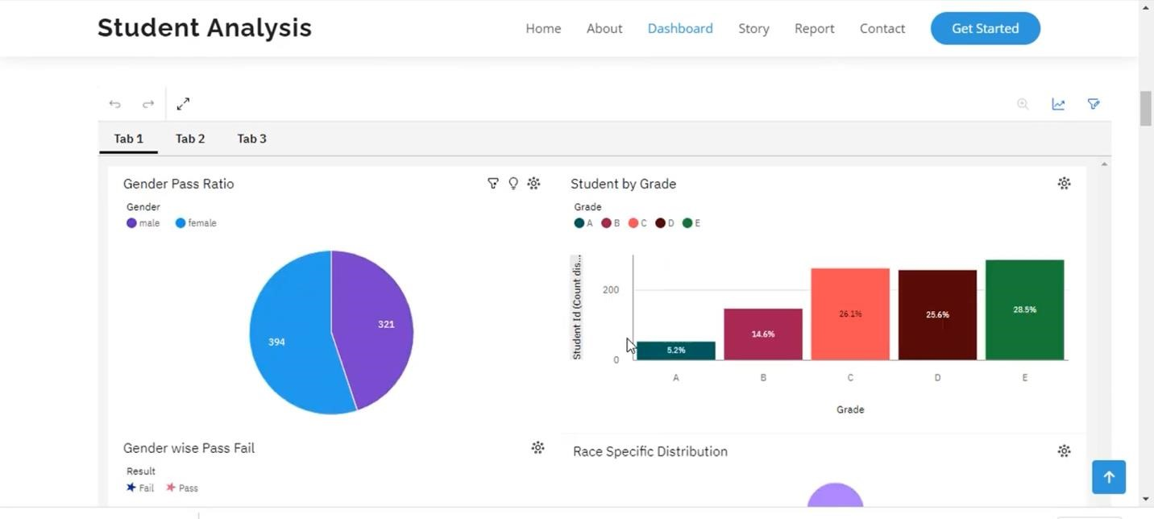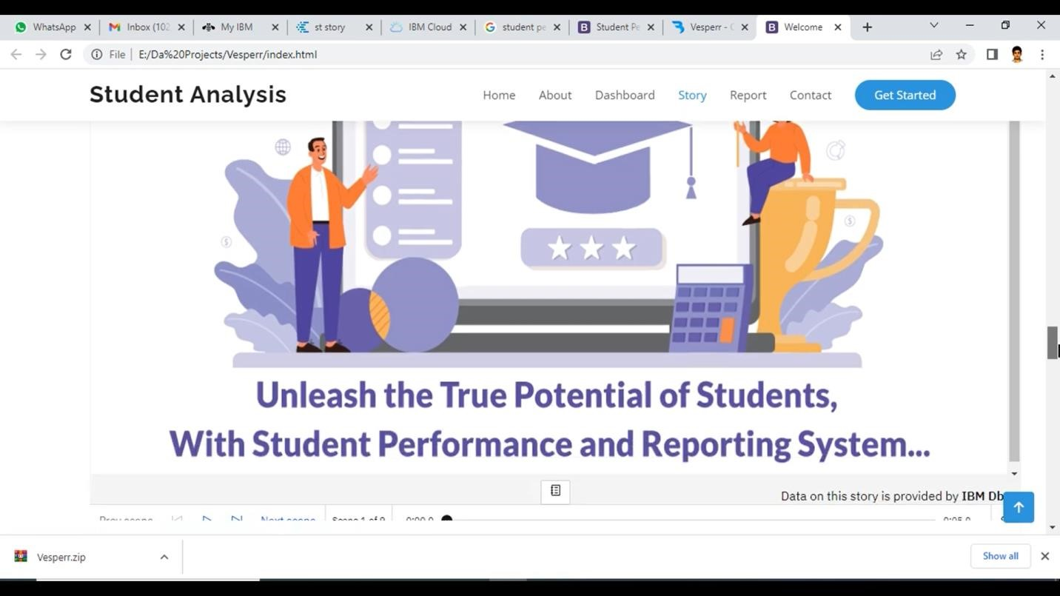

**Advantages:**

Student performance refers to the academic

achievements and accomplishments of students in various educational settings. High-quality student performance is associated with several advantages, both for the students themselves and for the broader society. Some of these advantages include:

1. **\*\*Personal Development:\*\*** Strong academic performance fosters personal growth, enhances self-esteem, and boosts confidence. Students who perform well in their studies often feel a sense of accomplishment and are more motivated to take on new challenges.

1. **\*\*Future Opportunities:\*\*** Good academic performance opens doors to a wide range of future opportunities. Higher grades can lead to admission into prestigious colleges, universities, and graduate programs, which can, in turn, lead to better career prospects and earning potential.

1. **\*\*Employability:\*\*** Employers often value academic excellence as an indicator of a candidate's work ethic, discipline, and ability to learn and adapt. A track record of strong student performance can enhance a person's employability and job prospects.
2. **\*\*Scholarships and Financial Aid:\*\*** High-achieving students are more likely to be eligible for scholarships, grants, and other financial aid, reducing the financial burden of education and making it more accessible.

1. **\*\*Positive Impact on Schools:\*\*** Students' performance impacts the overall reputation of educational institutions. High-performing students contribute to the positive image of their schools and can attract more talented students and teachers.

1. **\*\*Intellectual Development:\*\*** Academic success indicates that students are mastering essential concepts and skills in various subjects. This intellectual development helps them become critical thinkers and problem solvers, which are valuable skills in any profession.

1. **\*\*Contributions to Society:\*\*** Well-performing students are more likely to become productive members of society. They may go on to make significant contributions in their chosen fields, research areas, or community engagement, benefiting society as a whole.

1. **\*\*Promotion of Positive Learning Environment:\*\*** High-performing students can inspire their peers to strive for excellence, creating a positive learning environment that encourages healthy competition and academic growth.
2. **\*\*Parental Satisfaction:\*\*** Good academic performance can bring a sense of pride and satisfaction to parents and guardians who have invested time and effort in supporting their child's education.

1. **\*\*Higher Education Quality:\*\*** A student body with high performance levels can lead to a more engaged and stimulating learning environment in higher education institutions, enriching the overall educational experience.

It is important to note that student performance is not the sole determinant of success or potential, and various factors influence an individual's journey in life. Different students may excel in different areas, and each person's strengths and talents should be valued and nurtured. The pursuit of knowledge and personal growth is a lifelong journey that goes beyond academic grades.

**Disadvantages:**

While student performance analysis has its benefits in identifying areas of improvement and providing insights into academic progress, it also comes with certain disadvantages and challenges. Here are some of the drawbacks of student performance analysis:

* 1. **\*\*Overemphasis on Grades:\*\*** Relying solely on academic grades for performance analysis can lead to a narrow view of a student's abilities and potential. It may not consider other important aspects, such as creativity, problem-solving skills, emotional intelligence, and social competence.

* 1. **\*\*Standardized Testing Limitations:\*\*** Standardized tests, often used for performance analysis, may not fully capture a student's true abilities, learning style, or potential. Students with different learning preferences or skills may not perform well on these standardized assessments.

* 1. **\*\*Pressure and Stress:\*\*** Intense focus on performance analysis and high-stakes testing can create a stressful learning environment for students. It may lead to increased anxiety, burnout, and even a decline in academic motivation.

* 1. **\*\*Narrow Curriculum Focus:\*\*** An obsession with performance metrics may result in a narrowed curriculum, with educators feeling pressured to focus solely on topics directly related to the assessment. This approach may limit students' exposure to diverse subjects and practical life skills.

* 1. **\*\*Labeling and Stigmatization:\*\*** Student performance analysis can lead to labeling students based on their academic achievements, potentially stigmatizing those who perform below the expected levels. This labeling may affect their self-esteem and create a fixed mindset about their abilities.

* 1. **\*\*Teacher's Focus on Test Scores:\*\*** Teachers might feel compelled to teach to the test, emphasizing memorization and testtaking strategies instead of promoting deep understanding and critical thinking. This approach may undermine the overall quality of education.

* 1. **\*\*Comparative Analysis:\*\*** Performance analysis often involves comparing students against each other or against set standards. This competitive approach can create a sense of rivalry among students and may not consider individual progress and growth.

* 1. **\*\*Inequality and Bias:\*\*** Performance analysis may reveal disparities in academic achievement across different student groups. These disparities can be influenced by factors such as socioeconomic status, access to resources, and systemic biases.

* 1. **\*\*One-Dimensional Evaluation:\*\*** Focusing solely on academic performance may overlook a student's holistic development and the cultivation of other essential skills, such as creativity, teamwork, and leadership.

* 1. **\*\*Time Constraints:\*\*** Conducting thorough performance analysis for each student requires time and resources. In larger classrooms or schools with limited resources, it can be challenging to provide personalized feedback and support to every student.

To mitigate these disadvantages, educators and educational institutions should adopt a more comprehensive approach to student assessment. This approach could involve a combination of various assessment methods, such as project-based assessments, portfolio evaluations, teacher observations, and self-assessments. The goal should be to provide a well-rounded evaluation that considers each student's unique abilities, strengths, and areas for growth, rather than solely relying on standardized test scores or grades.

**Applications:**

Student performance analysis has numerous applications in education, benefiting both students and educators alike. One key application is the facilitation of individualized instruction. By analyzing student performance data, teachers can identify each student's strengths and weaknesses, allowing them to tailor their teaching methods and provide personalized learning experiences that cater to individual needs.

Additionally, performance analysis plays a crucial role in curriculum development. Educational institutions can evaluate the effectiveness of their current curriculum by examining student performance data. This data-driven approach enables them to make informed decisions on curriculum improvements and adjustments to better align with students' learning outcomes.

Another significant application of student performance analysis is in identifying learning gaps. By analyzing performance data, educators can pinpoint areas where students may be struggling and require additional support or intervention. This timely identification allows for targeted interventions and remediation, ensuring that no student falls behind. Furthermore, performance analysis is essential for teacher professional development. Teachers can reflect on their instructional practices by analyzing student performance data, identifying areas for improvement, and enhancing their teaching strategies.

Performance analysis also contributes to early intervention and special education. By monitoring student performance, educators can identify students with learning disabilities or special educational needs, enabling them to provide appropriate accommodations and support. Moreover, student performance data is crucial for school accountability and evaluation. Educational institutions can use this data to monitor their progress toward academic goals and meet performance standards set by governing bodies.

Tracking student progress is another valuable application of performance analysis. By regularly analyzing performance data, educators can monitor the academic growth of individual students over time, assess the effectiveness of teaching methods, and make adjustments as needed. Additionally, performance analysis plays a vital role in college and career readiness. Students can use their academic records to apply to colleges, universities, or vocational programs, showcasing their achievements and potential to prospective institutions or employers.

Beyond the classroom, performance analysis contributes to educational research and policy formulation. Researchers can analyze performance data to identify trends, correlations, and factors influencing student performance, providing valuable insights for shaping education policies and practices. Moreover, performance analysis facilitates communication between parents and teachers. Parents can gain insights into their child's academic progress through performance data and collaborate with teachers to support their child's learning journey effectively.

Finally, student performance analysis is crucial for resource allocation. Schools can use performance data to allocate resources efficiently, directing them to areas that need more attention or improvement. This data-driven approach ensures that resources are used to maximize their impact on student outcomes.

In conclusion, student performance analysis serves as a versatile tool in education, supporting personalized learning, curriculum development, teacher professional development, early intervention, accountability, college and career readiness, research, parental involvement, and resource allocation. By harnessing the power of performance data, educators can make informed decisions that promote student success and continuous improvement within the educational system.

# Conclusion

In conclusion, student performance analysis is a valuable and multifaceted tool that plays a crucial role in enhancing education at various levels. By examining student performance data, educators gain insights into individual learning needs, enabling them to provide personalized instruction and support tailored to each student's strengths and weaknesses. Additionally, performance analysis informs curriculum development, allowing educational institutions to refine their programs to better align with students' learning outcomes. It also aids in identifying learning gaps early on, facilitating targeted interventions and ensuring no student is left behind.

Furthermore, performance analysis empowers teachers to reflect on their instructional practices and continuously improve their teaching strategies. It fosters a culture of accountability in schools, as performance data is used to monitor progress towards academic goals and meet established standards. For students, performance analysis plays a vital role in preparing for higher education and future careers, as academic records become essential for college admissions and employment opportunities.

Beyond the immediate classroom impact, performance analysis contributes to educational research and informs policy formulation. It guides decisions that shape the education system to address the needs and challenges of diverse learners. Moreover, performance analysis strengthens the collaboration between parents and teachers, fostering a supportive environment for students' academic growth.

However, it is crucial to recognize that performance analysis is not without its limitations and potential drawbacks. It should be complemented by a broader understanding of students' holistic development and diverse talents beyond academic achievements.

Despite its limitations, student performance analysis remains an indispensable tool in education, guiding evidence-based decisionmaking, promoting continuous improvement, and ultimately striving to provide all students with the best possible learning experiences. By leveraging performance data effectively and considering it within a broader educational context, educators can work towards creating an inclusive, supportive, and enriching learning environment that empowers students to reach their full potential.

# Future scope

The future scope of student performance analysis holds significant potential to transform education and improve learning outcomes. With advancements in technology, data analytics, and artificial intelligence, performance analysis is expected to become even more sophisticated and comprehensive. One key area of development is the emergence of personalized learning algorithms. These advanced algorithms will analyze individual learning patterns, preferences, and strengths to generate tailored learning pathways for each student. This personalized approach will optimize the learning process, ensuring that students receive content, activities, and assessments that align with their unique needs.

Moreover, future performance analysis systems will likely move towards real-time tracking. With the integration of smart educational tools and learning platforms, educators will have access to up-to-date data on student progress. This real-time tracking will enable immediate interventions and timely feedback, allowing teachers to address learning gaps effectively and support students in real-time. The incorporation of multimodal assessment methods is another aspect of the future scope of performance analysis. These assessments will go beyond traditional exams and include project-based assessments, portfolios, peer evaluations, and more. This holistic approach will provide a comprehensive view of students' abilities and competencies, reflecting a more accurate picture of their overall performance.

As the recognition of social and emotional learning (SEL) gains importance in education, future performance analysis will also aim to evaluate and foster students' emotional intelligence, interpersonal skills, and well-being. The integration of SEL analysis will contribute to a more holistic understanding of student development, focusing not only on academic achievements but also on emotional growth and social competencies.

In addition, advanced predictive analytics models will play a pivotal role in early intervention. These models will be capable of identifying students at risk of falling behind or facing challenges much earlier in their academic journey. By providing educators with foresight, timely interventions and support systems can be implemented to prevent academic setbacks and ensure that students receive the necessary assistance when needed.

Furthermore, the future scope of performance analysis will extend beyond the classroom. Policymakers will increasingly utilize data-driven insights to shape educational policies and allocate resources more effectively, leading to evidence-based decision-making in education. Ethical data use and student privacy will remain paramount, requiring robust measures to ensure the responsible and secure handling of student data.

Overall, the future scope of student performance analysis promises to revolutionize education by providing personalized, datadriven, and adaptive learning experiences. By harnessing the power of technology and analytics, educators can gain valuable insights into individual student needs, create inclusive learning environments, and empower students to thrive academically and personally. However, this advancement should go hand in hand with a focus on ethical data practices, continuous teacher professional development, and a commitment to holistic student development to fully realize the potential of performance analysis in shaping the future of education.

